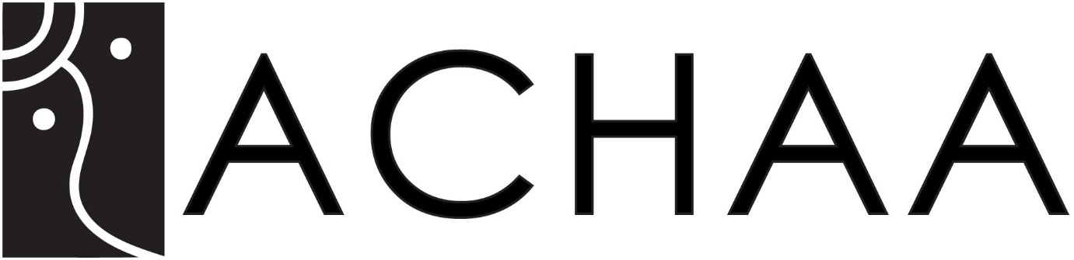

About this Privacy Policy

The NSW Aboriginal Culture, Heritage & Arts Association Inc has obligations concerning the collection, use, disclosure and storage of personal information. We elect to comply with the Australian Privacy Principles (**APPs**) under the *Privacy Act 1988* (Cth) (**Privacy Act**) as we are committed to respecting your privacy.

In this Privacy Policy, references to "we", "us" and "our" are to the NSW Aboriginal Culture, Heritage & Arts Association Incorporation number INC1401066 (ABN 83 933 088 435).

You consent to us collecting, holding, using and disclosing your personal information in accordance with this policy.

We will review and may update this Privacy Policy from time to time. The current version will always be available on this website.

What is personal information?

“Personal information” is information or an opinion about an identified individual or reasonably identifiable individual, whether true or not or whether recorded in material form or not.

What personal information do we collect and hold?

The personal information we collect and hold includes information about our members, customers, employees and contractors.

The personal information that we collect and hold may include an individual's:

* name;
* address;
* email address;
* the location from which you have come to the site and the pages within this site you have visited; and
* technical data, which may include IP address, the types of devices you are using to access the website, device attributes, browser type, language and operating system; telephone number and other contact details;
* workplace; and
* information provided to us via user surveys.

How do we collect and hold personal information?

We may collect personal information from the individual concerned or from a third party.

We may collect this information when you communicate with us through our website by e-mail or through a written application.

We have processes in place to ensure that our records remain accurate, complete and up to date, including by verifying the information with you or from other sources each time you use our services.

These records are retained for up to five years as recommended by the ATO.

If the information is no longer required by us for any purpose for which it was collected and is no longer required by law to be retained by us, we will destroy or de-identify the information.

Why do we collect, hold, use and disclose personal information?

We may collect, hold, use and disclose personal information for the following purposes:

* to enable you to access and use our website and services;
* to operate and optimise our website and services to improve the experience of all users;
* to send support and administrative messages, reminders, technical notices, updates, security alerts, and information to you;
* to send e-newsletters to which you have subscribed; and
* to comply with our legal obligations

To whom do we disclose personal information?

We may disclose personal information to the following third parties for the purposes listed above:

* our marketplace vendors; and
* service providers so that they may perform services for us or on our behalf.

When we disclose personal information to third parties, we make all reasonable efforts to ensure that we disclose only relevant information and that it is accurate, complete and up to date and that the third party will comply with the Privacy Act in relation to that information.

We may disclose personal information in other circumstances, where the person concerned has consented to the disclosure, or where we are expressly permitted to do so by the Privacy Act.

These other disclosures may include where:

* You would reasonably expect the disclosure to occur (for example, quality assurance purposes or training);
* We are authorised or compelled by law to disclose;
* it is necessary as part of the establishment or defence of a legal claim;
* it is requested by an enforcement agency such as the police; or
* it is a necessary part of an investigation following a complaint or incident.

Disclosure of personal information outside Australia

We do not disclose personal information to anyone outside Australia.

Security of your personal information

To protect personal information from misuse and loss, and from unauthorised access, modification or disclosure:

* our staff are trained in how to keep your information safe and secure;
* we store your hard copy and electronic records in secure systems; and
* we use trusted contracted service providers (including cloud storage providers).

However, we advise that there are inherent risks in transmitting information across the internet, including the risk that information sent to or from a website may be intercepted, corrupted or modified by third parties.

The personal information of our employees, systems and most of the third parties we share information with are located in Australia, with some of this personal information stored in secure cloud systems. We require from all our cloud suppliers that such information is to be hosted in Australia.

Links

Our sites may have links to other websites not controlled or owned by us. We are not responsible for these sites or any consequence of a person's use of those sites. In particular, we are not responsible for the privacy policies or practices of the operators of other websites. We recommend that you review the privacy policies of those external websites before using them.

How can I access or correct my personal information?

We have measures in place to ensure that the information we hold about individuals is accurate, complete and up to date. If you learn that personal information we hold about you is inaccurate, incomplete or not up to date you should contact us so that the information can be updated.

If you wish to see what information we hold about you, you can ask us for a copy.

If we refuse to correct or update your information, you may request that we make a note on your record that you are of the opinion that the information is inaccurate, incomplete, out of date, irrelevant or misleading, as the case may be.

There is no charge for requesting access to your personal information, but we may require you to meet our reasonable costs in providing you with access (such as photocopying requests, postage or costs for time spent on collating large amounts of material).

You will be notified of any likely costs before your request is processed.

How can I make a complaint regarding my privacy?

If you have a complaint or concern regarding our handling of your personal information or think that your privacy has been affected you should contact us as detailed below for an examination of your complaint or concern. If you remain unsatisfied with the way in which we have handled a privacy issue, you may approach an independent advisor or contact the Office of the Australian Information Commissioner (OAIC). . See [www.oaic.gov.au](http://www.oaic.gov.au/) for how to make a complaint.

Contact us

**Email:** accha@mgnsw.org.au

**Privacy Officer** Stephan Miller